Curriculum Vitae

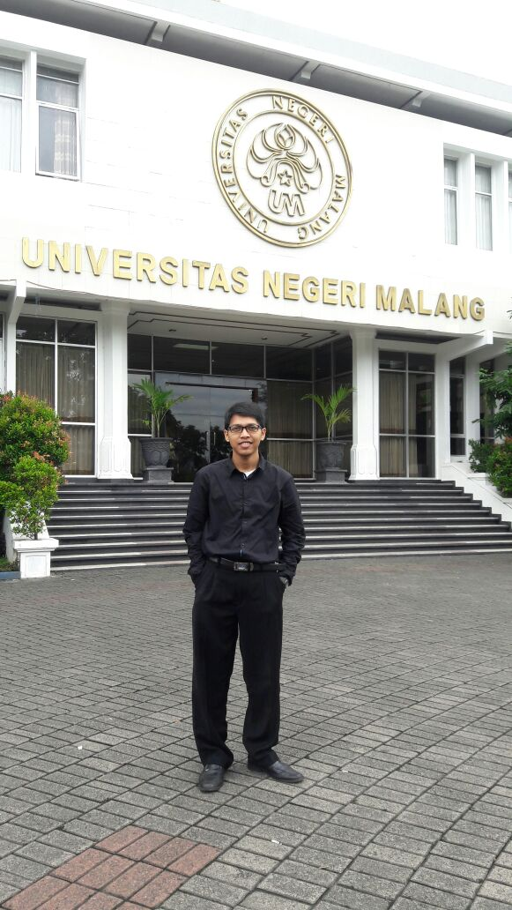
Mukhammad efendi was born on 10th November, 1994 in Pasuruan. His fathers’ name is Kamaludin and his mother’s name is Siti Solikha. He is the first child of two siblings. His young sister’s name is Dwi Novi Arianti. He began his first formal education in TK Roudhatul Jannah in Tambak Sari, Pasuruan. His elementary school was in SDN Plinggisan from which he graduated in 2007. He continued his education in SMPN 6 Pasuruan and graduated in 2010. Afterwards, He studied in SMK Shalahudin Pasuruan and finished his studied in three years.
In 2013, he continued his study in State University of Malang trough BidikMisi Scholarship Program (a scholarship scheme that targets talented students, particularly from poor families, to pursue tertiary education) and was accepted. He began his first teaching career as English teacher and also I am working as a Translator and Writer.

