PORTOFOLIO DESAIN
HAIKAL AUFAR
201531041
- WPAP (Wedha’s Pop Art Portrait) Presiden Jokowi
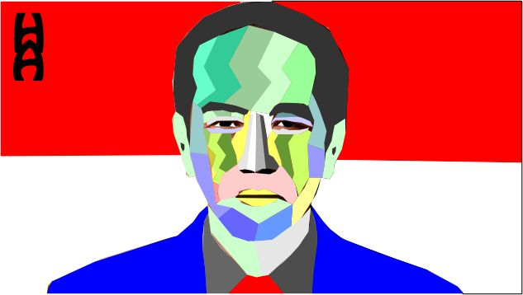

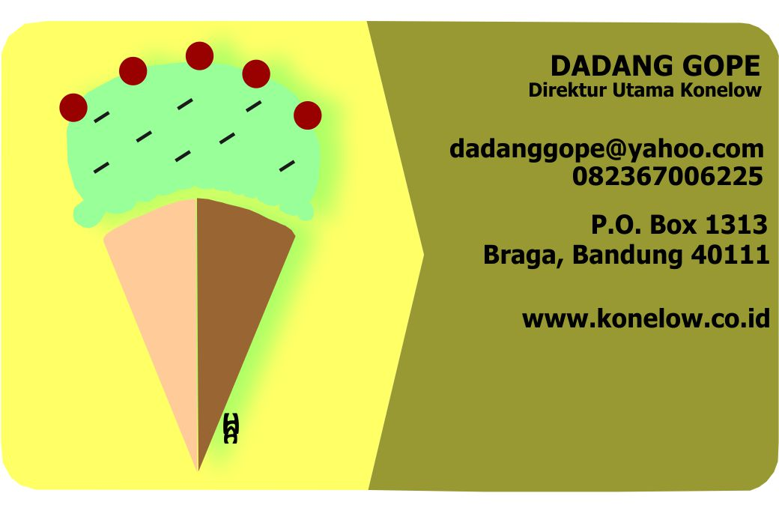
- Kartu Nama

- Poster Promosi

