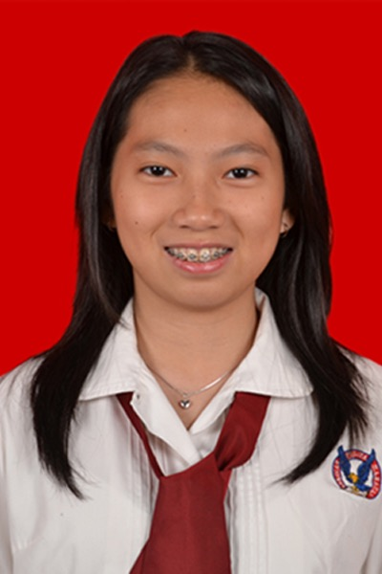

Curriculum Vitae

Personal Details |  | Full name : Lisa Agustina  Gender : Female  Place & Date of Birth : Bogor, 8 August 1995  Nationality : Indonesian  Address : Vila Indah Pajajaran Jl. Kertanegara No. 8, Bogor 16158.  Mobile phone : 08111103088  Email : lisaagustinagui@gmail.com  University : Faculty of Medicine Universitas Pelita Harapan.
Education Backgrounds |  | 2013 – present : Medical Doctor. Faculty of Medicine Universitas Pelita Harapan, Indonesia
Experiences |  | 2014 – present : Tim Bantuan Medis Chrestotes at Faculty of Medicine, Universitas Pelita Harapan.  - 2014. Basic Life Support Training.  - 2014. Mass Casualty Response Training.  - 2014. Sport Injury Management Training.  - 2015. Social Service: Stroke Health Promotion. (Committee)  - 2015. Water Rescue Training.  - 2015. Basic Minor Surgery Training.  - 2015. Sirkumsisi Masal. (Committee)  - 2015. Basic Life Support Training. (Committee)  - 2015. Emergency Case Management  - 2016. Social Service. (Committee)  2014 – present : CIMSA [Indonesia IFMSA] at Faculty of Medicine, Universitas Pelita Harapan.  2014. CIMSA Day Out: Career pathway introduction at Lembaga Pemasyarakatan Anak Pria Tangerang. (Committee)  2014. Pre-Medical School Introduction. (Committee)  2015. CIMSA Basic Training: Communication, Project Management, Think Outside the Box, Leadership & Teamwork.  2015. CIMSA National Leadership Summit 2015: Medical Students’ Contribution Beyond 2015 – To Ensure Healthy Lives.  2015. Career Day Seminar and EduFair: Non-Governmental Organization on medical response & health and Specialist Education in Indonesia. (Committee)  2015. Human Rights Day: Disability Rights. (Committee)  - 2016. Human Rights Day: Disability Rights. (Committee)  2015 Summer electives CMC Vellore.

