CURRICULUM VITAE
DWI WISNU SUSILO, ST
Simo Pomahan Baru Barat 6/8
Surabaya 60181

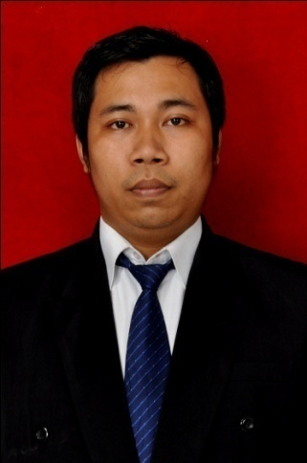
- PERSONAL DETAIL
- Place and Date of Birth : Surabaya, August 03, 1986
- Citizenship : Indonesian
- Sex : Male
- Religion : Moslem
- Marital Status : Married
- Address : Simo Pomahan Baru Barat 6/8
- Telephone : 085203631855
- Email : dwiwisnu2@gmail.com

- FORMAL EDUCATION
LEVEL | PERIODE | SCHOOL NAME | CITY | MAJOR | GPA
Bachelor’s Degree | 2006-2011 | Sekolah Tinggi Tehnik Surabaya (STTS) | Surabaya | Electrical Engineering | 2,75
Senior High Shcool | 2002-2006 | SMK Negeri 5 Surabaya | Surabaya | Electrical Engineering | 8,9
Junior High Shcool | 1999-2002 | SMP Taman Pelajar | Surabaya
Elementery High Shcool | 1993-1999 | SD Negeri Simomulyo I | Surabaya

- SKIILS
- Microsoft Office : Excel, Word, Power Point, & Visio
- Microsoft Project
- Photoshop
- Corel Draw
- Autocad 2D
- Trouble shooting Computer.

- Working Experience
- PT. Atamora Tehnik Makmur, as Project Procurement Engineering Support at CNOOC Banuwati K-Project Gas Compressor Platform, Surabaya.
Start march 18, 2013 Present (1 Years 10 Month).

Job Description :
- Sourcing qualified contractors (Structural, mechanical, electrical, Instrument & Services) for the project.
- Ensures that the procurement process within project follow procurement procedure.
- Assists tender/project team to issue RFQ.
- In cooperation with the Lead Engineer to prepare Vendors & Suppliers list for the project.
- Ensure that the technical specification proposed by vendors and suppliers conform to the Client’s requirement.
- Release PO (Purchase Order) or OC (Order Confirmation) for deal approved project.
- Ensure material arrive on schedule.
- Calculation TKDN ( Tingkat Kandungan Dalam Negeri ) after project completion.

- PT. Atamora Tehnik Makmur, as Procurement Engineering Support at SANTOS Pty.Ltd Callout Fabrication & Modification Services. Lamongan Shore base.
Start May 18, 2012 - November 05, 2012 (6 Month).

Job Description :
- Prepare blanket release (BR) as request Company.
- After release BR for company, Procurement searching for vendor supply.
- Release PO (Purchase Order) for deal approved project.
- Prepare for Invoice.
- Prepare Time sheet for workers.
- Calculation TKDN ( Tingkat Kandungan Dalam Negeri ) after project completion.

- Organization Experience
- HIME (Himpunan Mahasiswa Electro) as Secretary Period 2008-2010.
- Committee Robosumo period 2006-2007

